# Review of the decorator pattern implemented by Group 2

### Authors:

Georgi Chishirkov

Ilia Nikushev

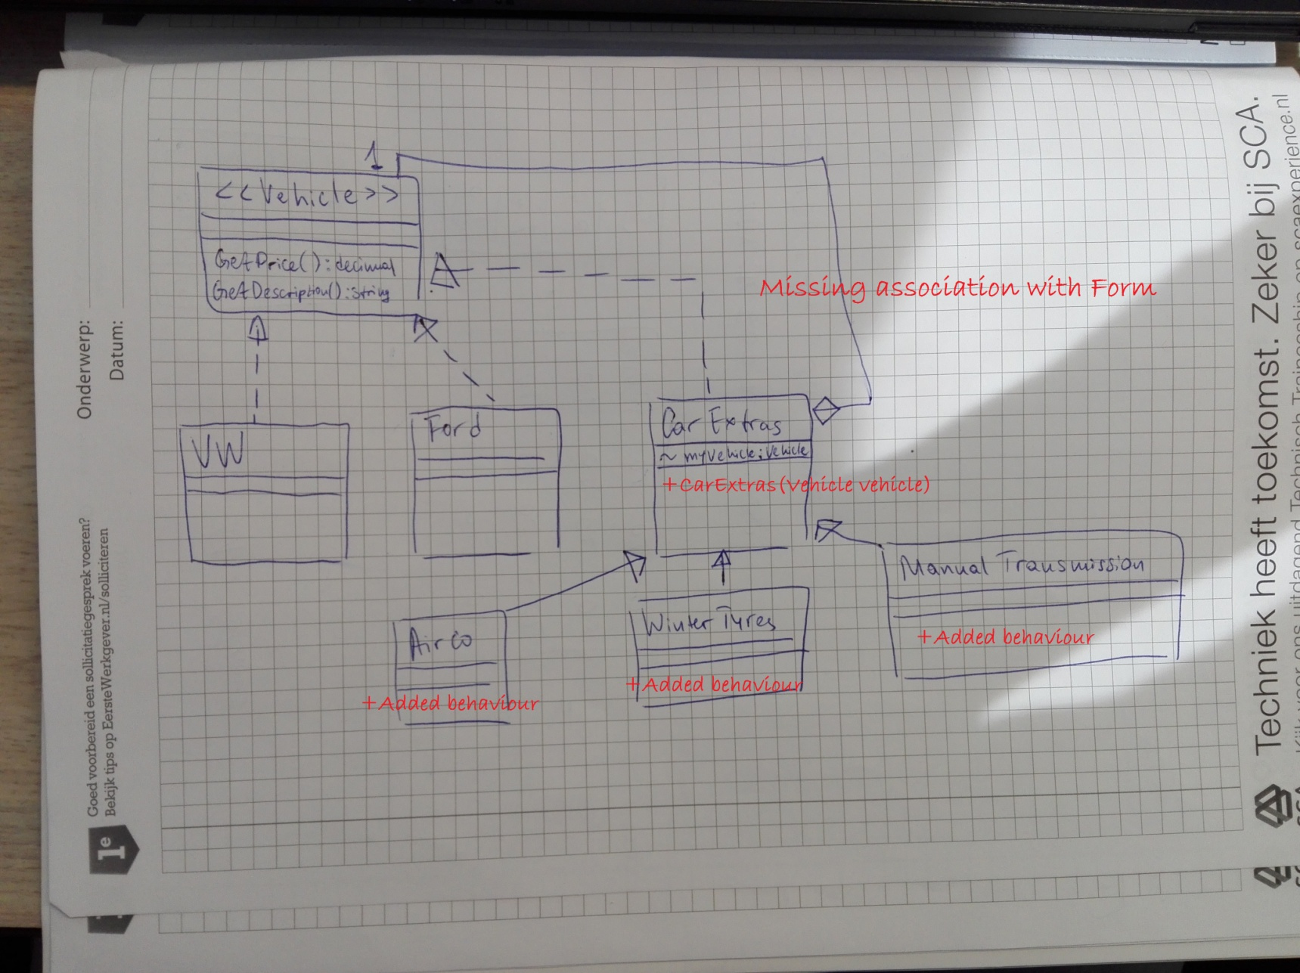From reviewing the code and the UML diagram we can say a couple of things:

1. In both the UML diagram and the code we are missing methods that give some added behavior to the concrete classes. The 3 classes are pretty much the same, the price and description methods are different but adding something that adds extra things to the price (Example: maintenance fee for the Airco just to demonstrate) or a type (Tyres can be radial etc).

2. In the UML we are missing the constructor for the CarExtras class which is however specified in the code.

3. Lastly there should be some association with the Form as it does use objects from the classes.

In summary the actual implementation is very good and true to the decorator pattern that was shown to us. There were some mistakes but the grade for this solution is a solid 9 out of 10.